**TASK-01**

Magic Date

**EXPLANATION:**

The program asks the user to input the date, month and time in the format mm/dd/yy. If the user in month section mistakenly enters a character or integer greater than 12, the program gives an error and returns the user to the starting of the program. Same happens in case of day and year. After that the program multiplies date and month. If they are equal to the year user entered then program output’s as “magical date” otherwise “not a magical date”.

**INPUT:**

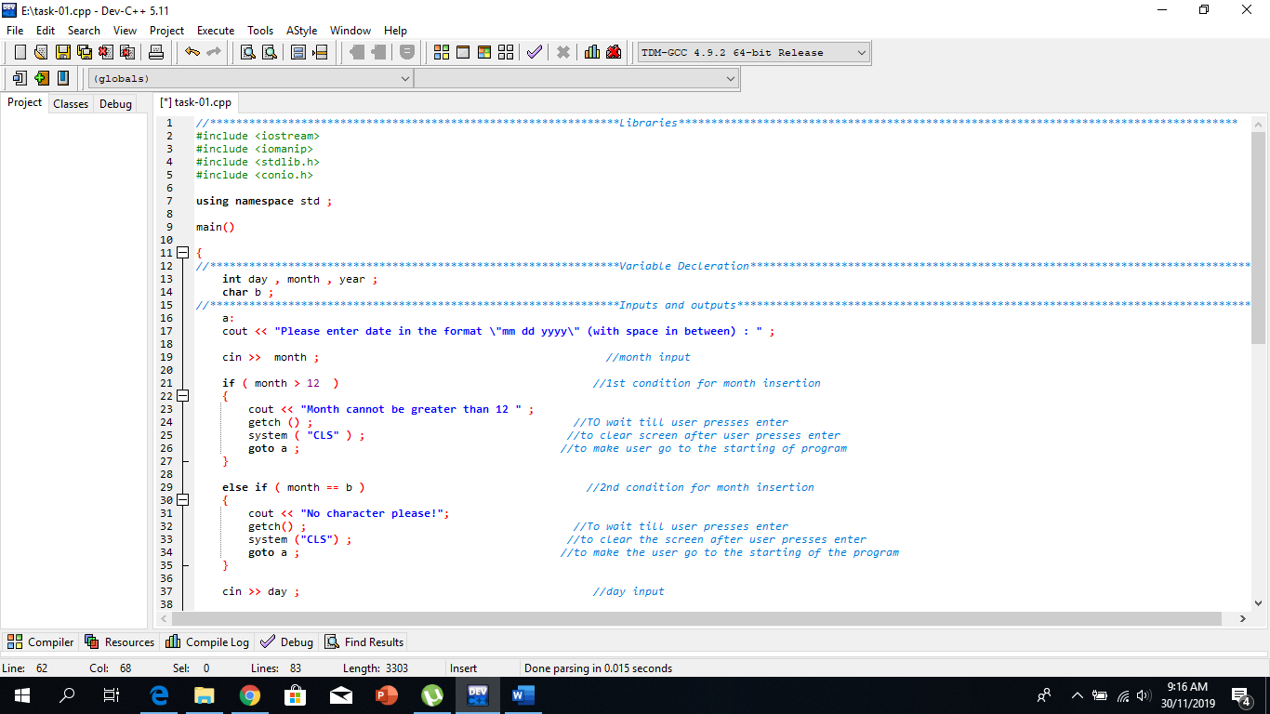

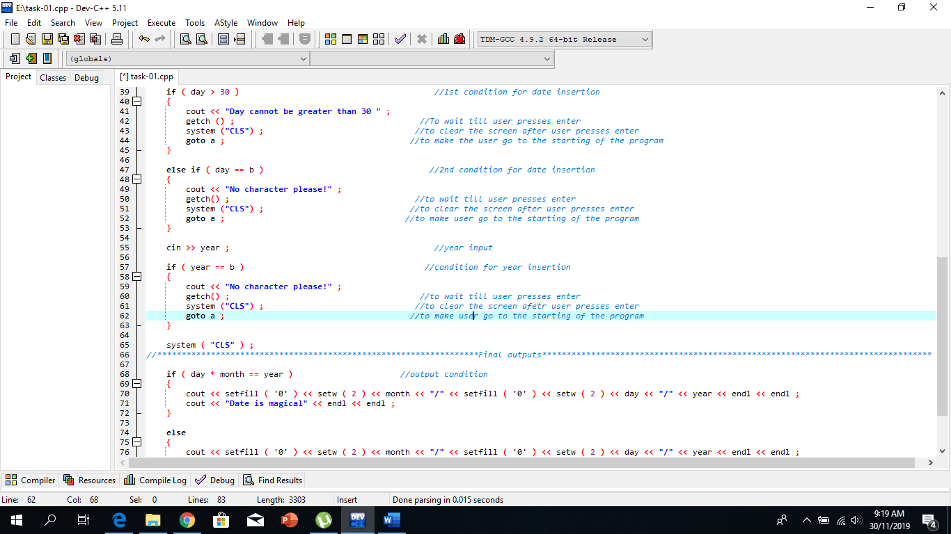

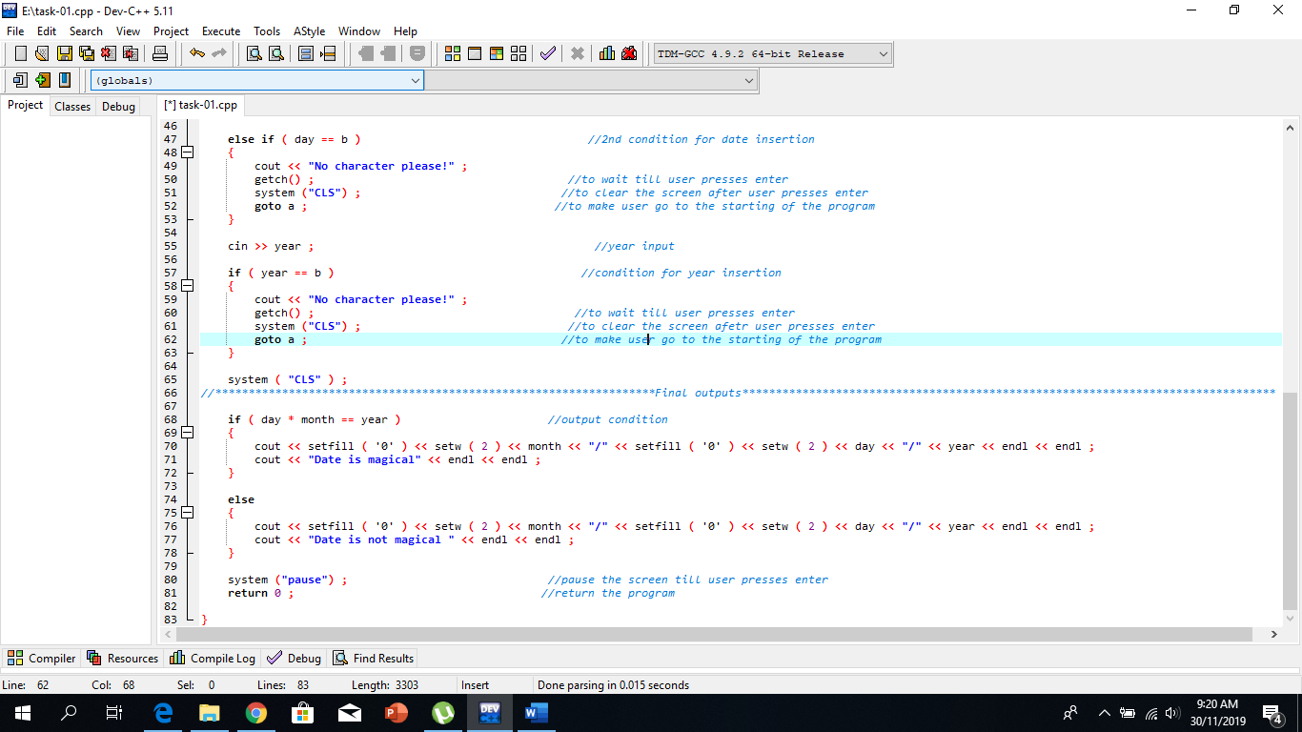

**OUTPUT:**

